Hotel management system

MEMBERS:

Reg no:SP20-BSE-077(Nimra Zaigham)

SP20-BSE-100(Zahra Saeed)

**Hotel management system**

**The module of hotel management system includes**

* **Book a room**: name, phone number, email, room type the want along with few other entries are added, few are verified too. And are added to the “information.txt “file.
* **Check in** : check in form is displayed iteratively personal information is filled , the phone number and email is verified and stored .
* **Cancel Booking**: booked customer’s name is added and the booking is cancelled while the file gets updated.
* **See Booking Details :** name is asked and all of the customer’s booking details are printed .
* **See Check In Details** : name is asked and all of the customer’s Check-In details are printed.
* **See all booking Details**: every customer’s booking is displayed
* **See all Check In Details** :every customer check in detail is displayed
* **Check Out**: checkout details are added and stored in the file
* **See all Check Out Details**  :all the checkout details are printed

The project includes the use of

**Interface** ,**Abstract class ,Abstract method ,Inheritance ,Instance of object , serializable , access and visibility modifiers, final method , final class, instance/static variable and methods , super and this keyword, Date class ,Object class ,Type casting , toString() method, Instantiation , Accessors and mutators , constructor, composition , Array of objects ,Polymorphism , Exception handling , Generics->Arraylist File handling**

.

When the program starts no data is previously stored in file so the line **”there is no previously saved data is printed “**

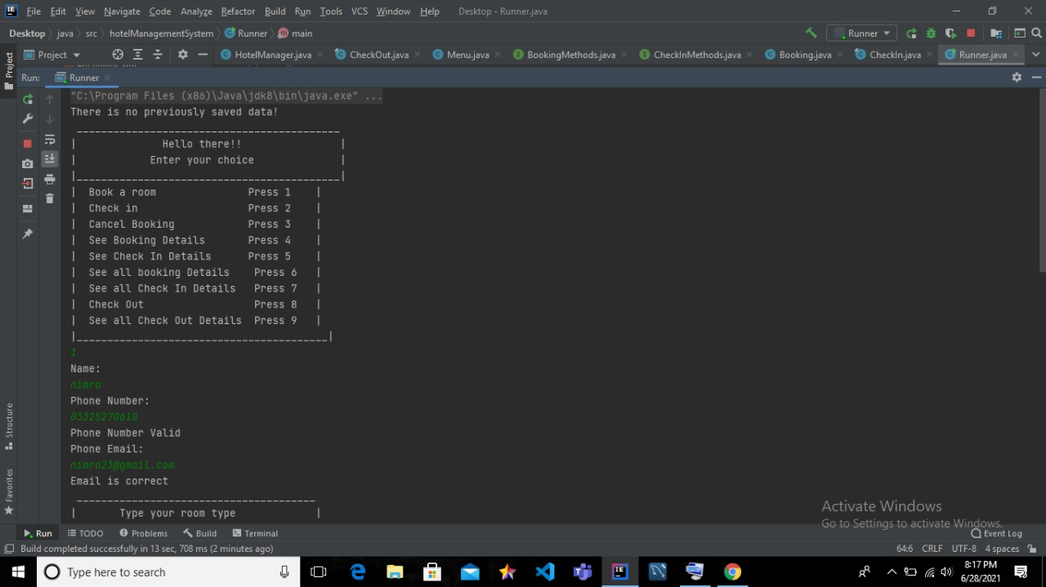

But when data is stored in file and the file becomes populated a path is displayed

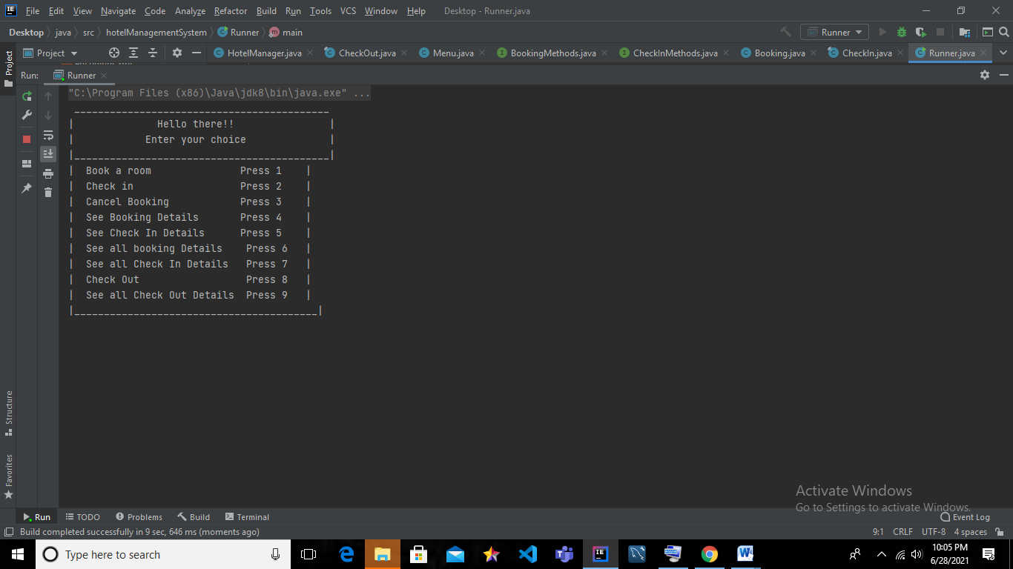

The path

**1.Booking**: booking details required are asked and are filled by the customer . all the data is stored in the file and the file updates



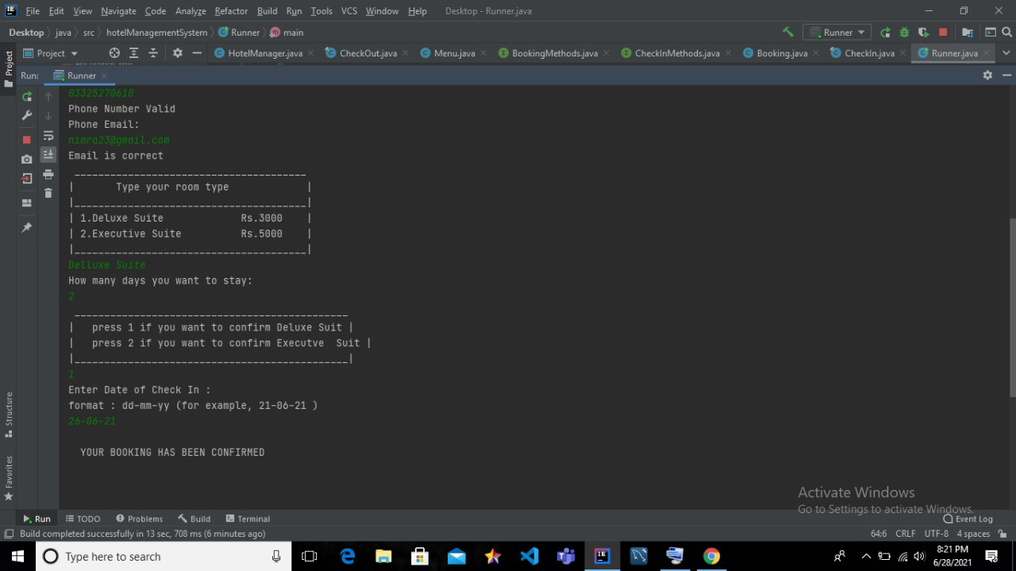

Figure 1 Complete Booking of Nimra

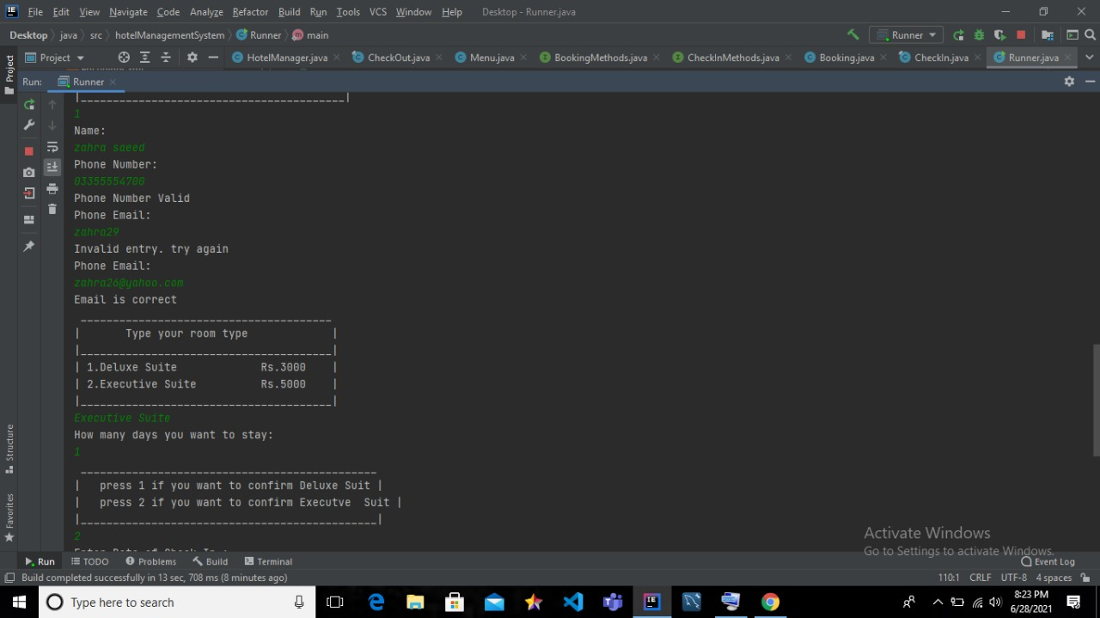

Figure 2 another customer booking

**2.See all bookings:**

When the method is called to display ,the data stored when the bookings were made is displayed ,includes all the booked customers

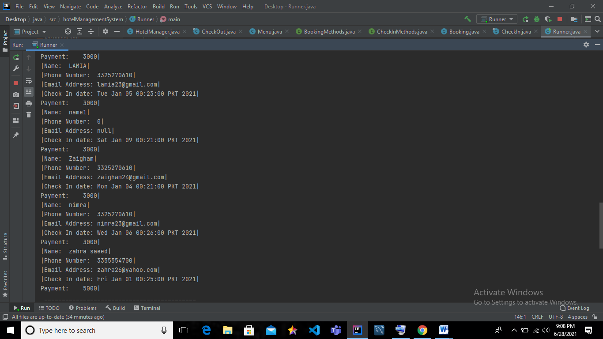

**3.Cancel booking:**

After a customer named Lamia wants to cancel her booking her name is asked and the bookings list deletes her booking slot, so calling the method of show all bookings prints:

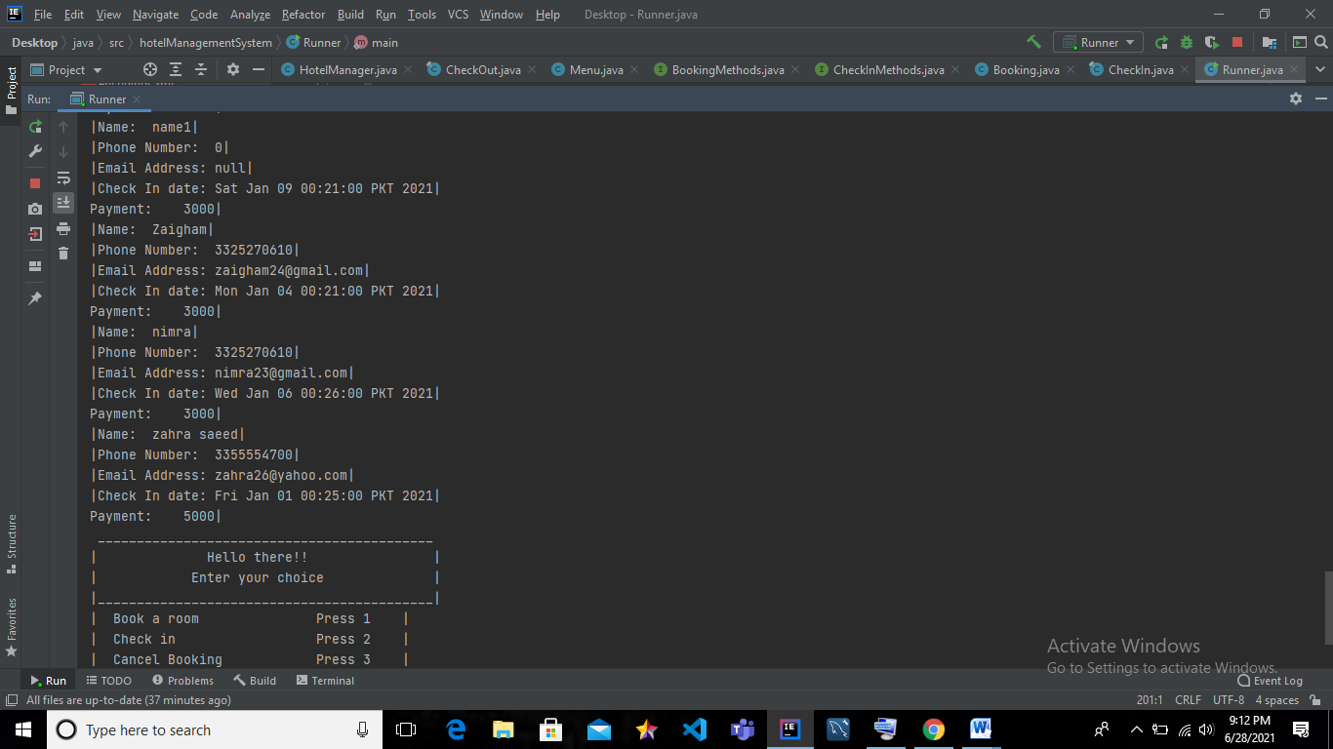

Figure 3 after deleting A customer name lamia booking

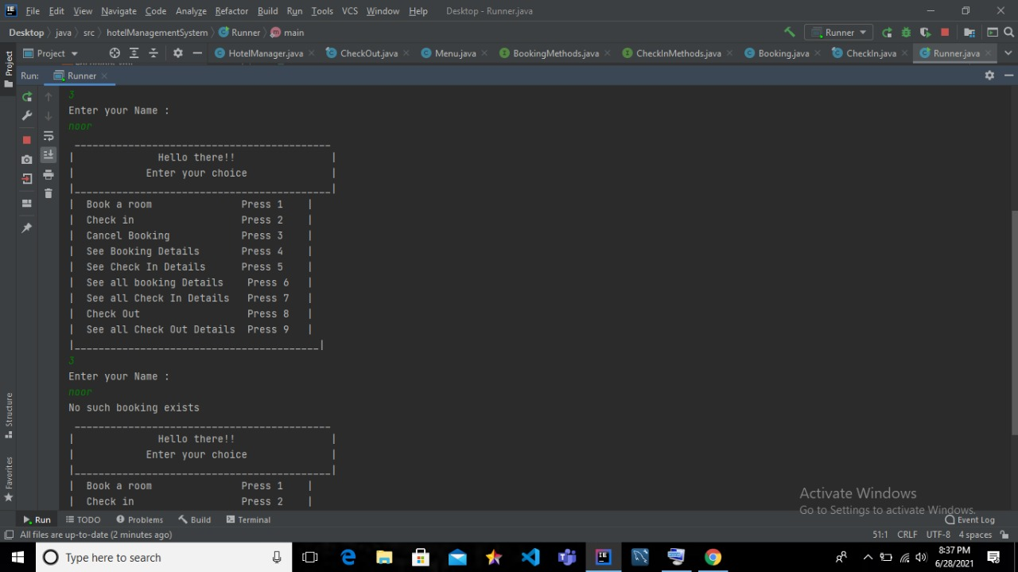

Invalid name shows no such booking exists

Figure 4 Invalid name is added to a non-existing booking

**4.See booking details:** name of the customer is asked and all his/her booking details are displayed.

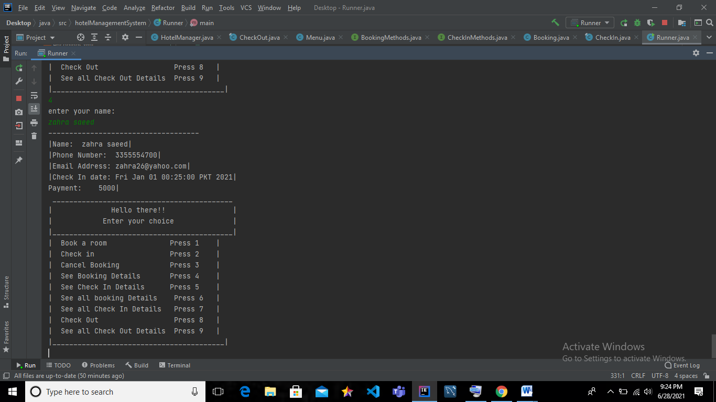

**booking details**

Figure 5 Booking details of a person is printed

**5.Check In: check in form is displayed user is asked to fill the form ,**

**Phone number, email id is checked if it is valid or not all the data is stored in file and the file is upgraded.**

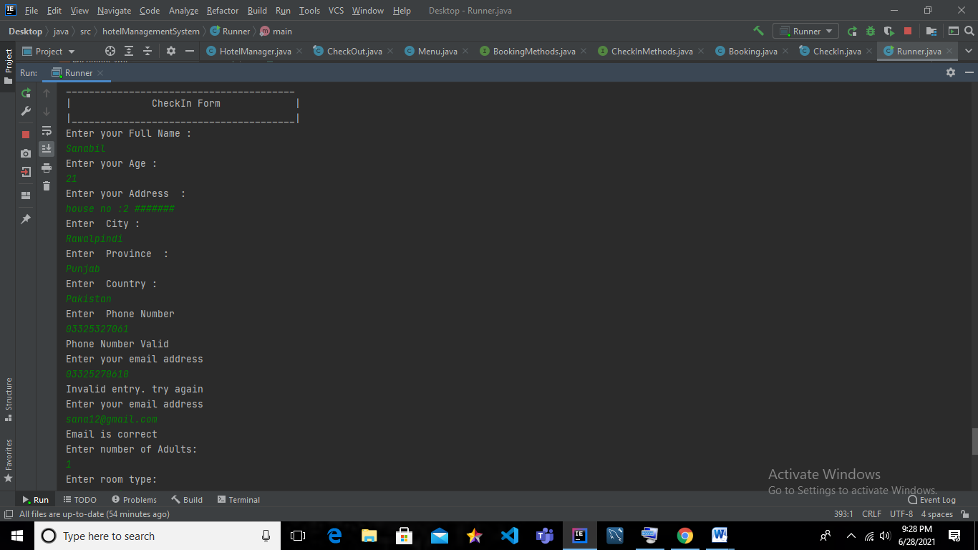

E-mail verification is added

Phone number Validation is added

Figure 6 Check IN FORM

**Display check in detail of a customer:**

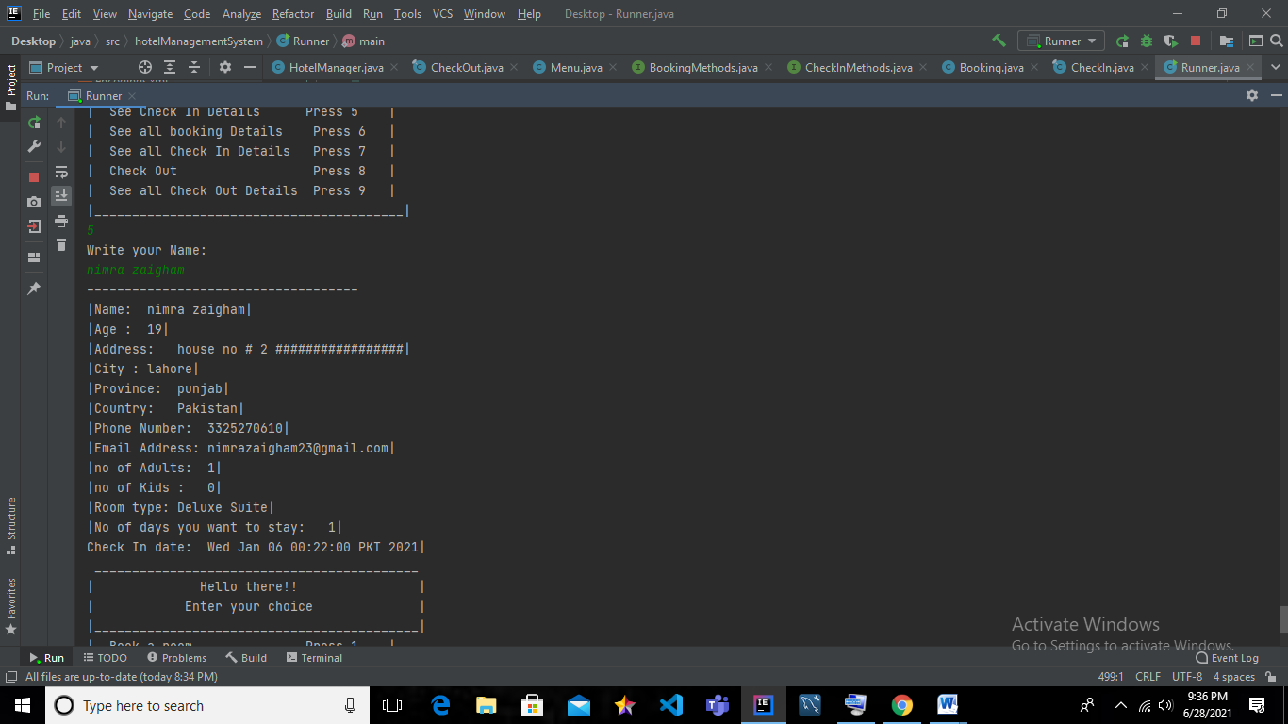

**Check in details**

Figure 7 Check-In form of a customer:

**6.Display All Check-In’s:**

the method of display all check in is called ,every customers check in detail stored in file is displayed .

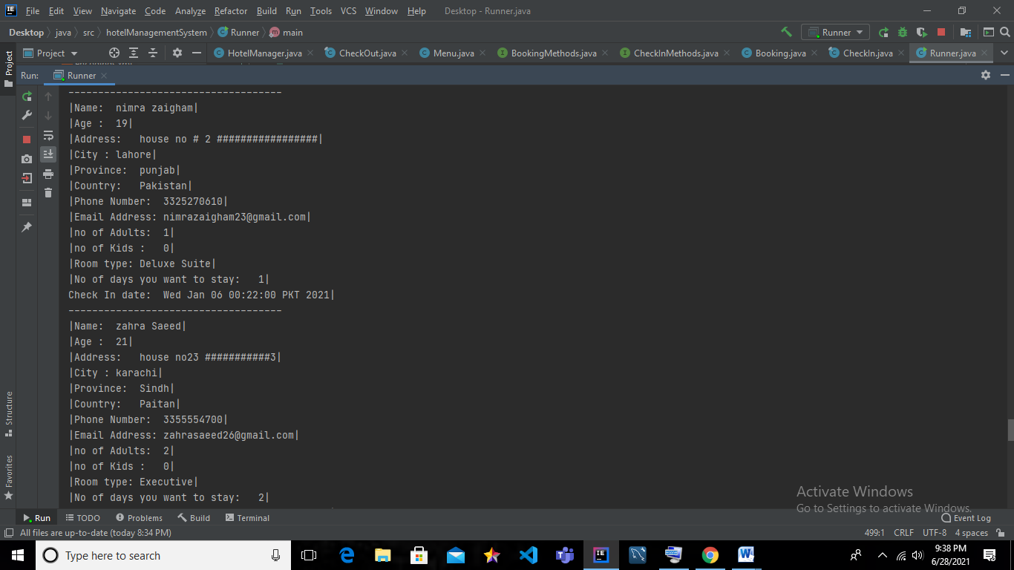

Figure 8 All the check in's stored in file are printed

**7.Check –Out: When checking out from the hotel few requirements are again asked all the data entered is stored in file .**

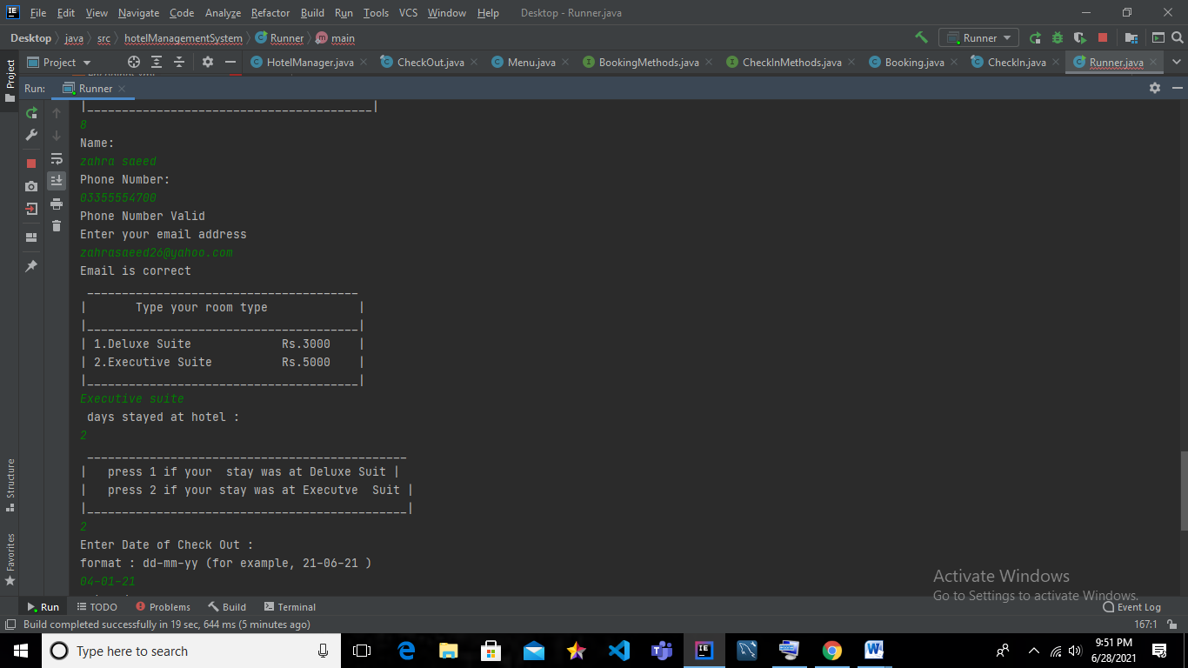

Check-out form

Of a customer

Figure 9 check out form of a customer

**8.check out** details are printed:

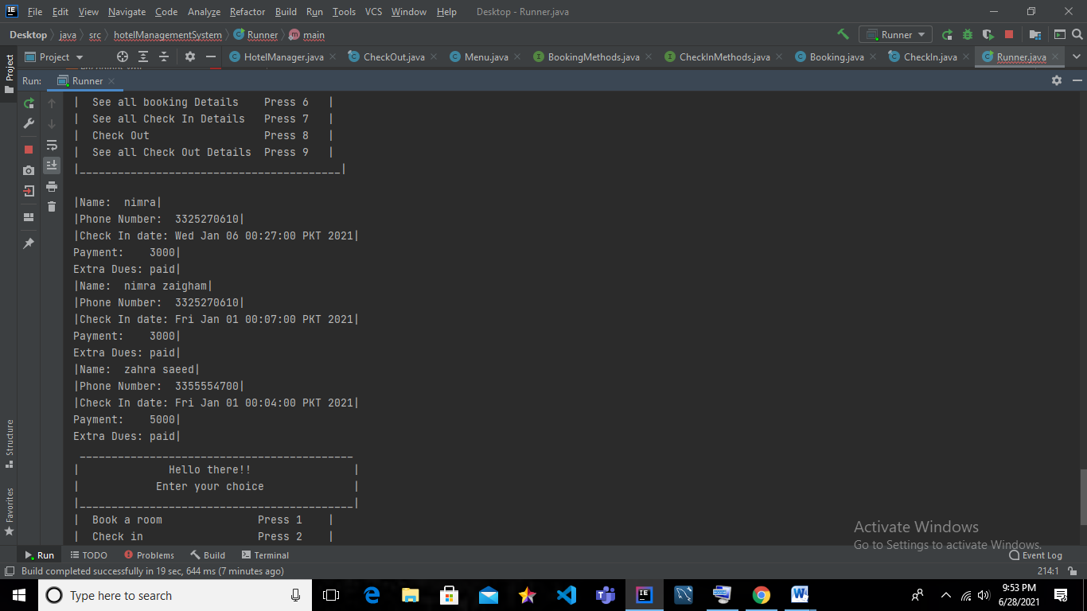

**All the check-out details are printed**

Figure 10 see all checkoutdetails method is called